S2 Bio Plants Homework2 Leaf and Asexual Reproduction
DO NOT write on these sheets Number ______

1. How well do you know the parts of a leaf?
a) I have lots of chloroplasts as I am the main site of photosynthesis. Which leaf cell am I?
b) I am transparent so that light can pass easily through me. Which leaf cell am I?
c) I have lots of small holes in me. Which layer of the leaf am I?
d) We can bend and straighten to open and close the stoma pore. Which leaf cells are we?

2. Imagine you are a molecule of carbon dioxide. Write a description of your experience as you move from the air into a leaf and become a raw material in photosynthesis.
Include all of the following words in your description.
diffusion light energy palisade mesophyll
stomata spongy mesophyll water glucose

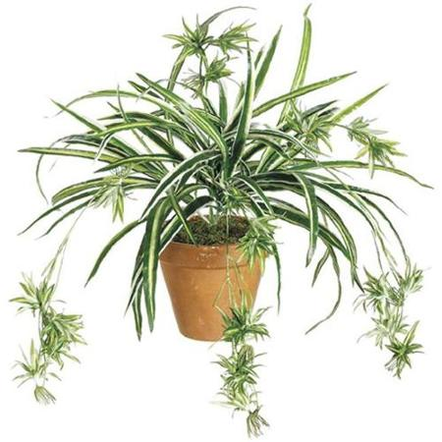
3. The picture on the right is Mrs Trellis’ spider plant. She has two sisters and would like to give each one a plant exactly like this but cannot afford to buy a new ones.
Using your knowledge of asexual reproduction in plants explain to Mrs Trellis how she can use her plant to give her sisters a plant each.

4. Using the letters arrange the following statements in the correct order to show the sequence of events in asexual reproduction in potatoes. Start with A.
A. adult plant sends food down to the roots for storage
C. tubers remain dormant under the soil
D. each tuber grows shoots
E. adult plant dies
B. tubers use their food store to grow into new plants

F. tubers swell up under the soil

