Credit 2010

1
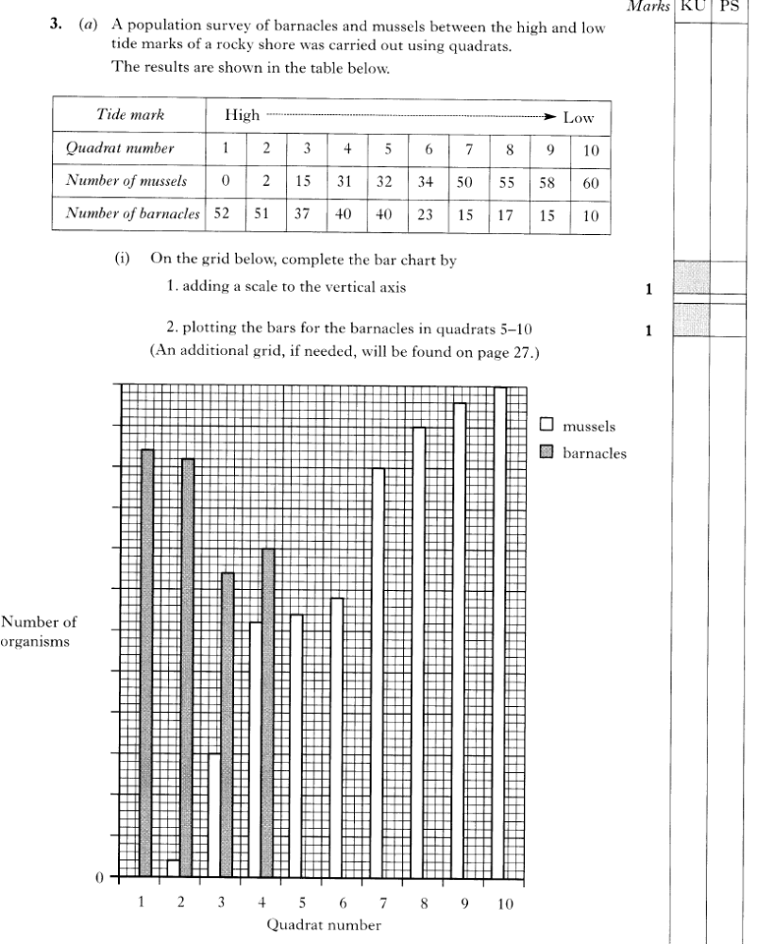
G2004
2
2


G2010
3
4
Some students wanted to see what effect people walking on a ﬁeld had on the number of different
plants growing there. In order to sample the plants, they used a quadrat (1mX1m), as shown in the diagram.
The students investigated the numbers of daisies, dandelions, buttercups and plantains growing in
areas that were walked on and areas that were not.
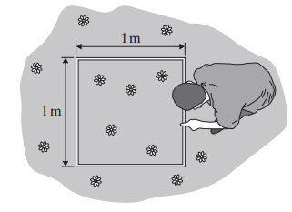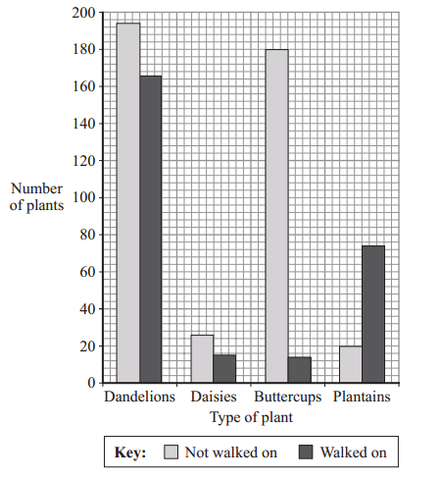

(i) Which of the following techniques would make the investigation as fair as possible?
A- placing all the quadrats on areas that had been walked on
B- placing all the quadrats where there were lots of plants
C- placing all the quadrats randomly in the two different sample areas
D- placing all the quadrats where all four types of plant were growing

(ii) The students found that the mean number of dandelions in a 1 m2 quadrat was 4.
The area of the field was 1000 m2- How many dandelions were there likely to be in the whole field?
A- about 4 B- about 400 C- about 1000 D- about 400011

The bar chart shows the results.
(iii) How many daisies grew in the area which was walked on?
A- 15
B- 25
C- 30
D- 40

(iv) Which type of plant grew best in areas that were walked on?
A- dandelion B- daisy C- buttercup D- plantain

5


(c) How would you measure each of the abiotic factors that you have identified?

1st Factor _________________________________________________________________________

2nd Factor ________________________________________________________________________

What possible problems might you encounter when sampling these factors and how could these be avoided?

1st Factor _________________________________________________________________________

2nd Factor ________________________________________________________________________

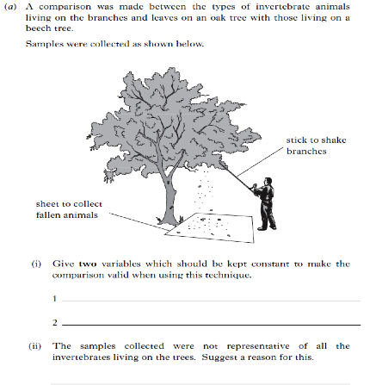
6

Estimating total numbers.
7
A biologist sampled worms in a field with a 0.25m² quadrat thrown at random. (He cruelly threw soapy water on the ground to make the worms come to the surface)
Using this data, estimate the number of worms in the field shown below.

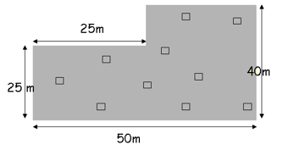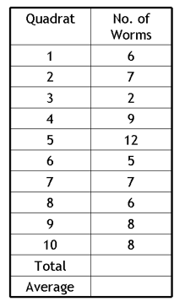

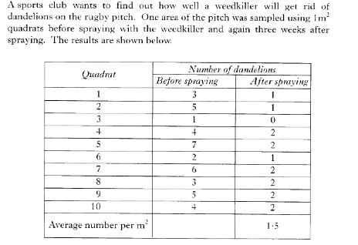
8
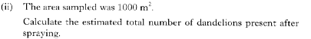


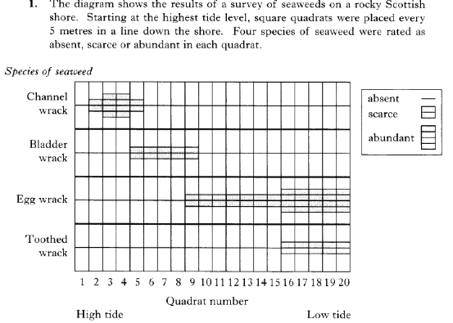
9


10

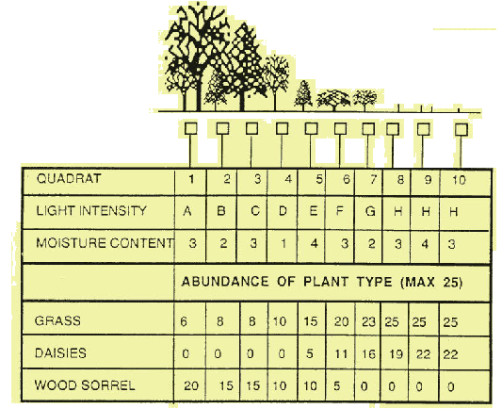
Light intensity
A (low) to
H (high).

Soil Moisture
1 (dry) to
8 (wet)
a.Describe what happens to light intensity as you move along the transect from the wood to the field.

b. What is the pattern to moisture values as you move into the field from the woodland?

c. Describe what happens to the abundance of grass as you move along the transect line from the wood to the field.

d. Explain the probable reason for the change in the abundance of daisies and grass as you move out of the woodland.
e. Describe what happens to the abundance of wood sorrel as you move out of the wood.
f. Give a possible reason for the change in wood sorrel abundance.

g. Do you think that the change in the moisture content of the soil can be used to explain the observed difference in distribution of the plants as you move out of the woodland? Give a reason for your answer.

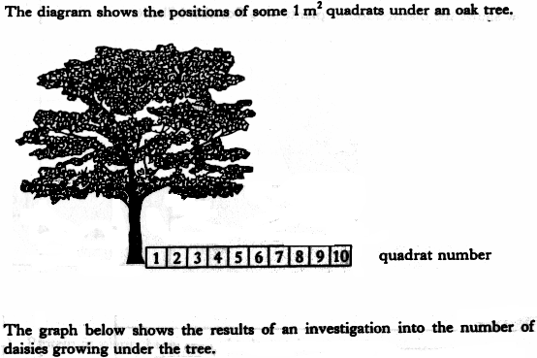
11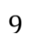

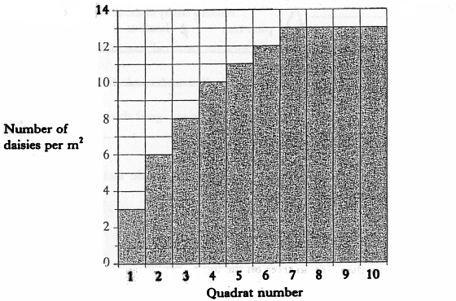

(a) How many daisies were found in quadrat 6?

________________________

(b) Which quadrat closest to the tree contained more than 10 daisies per m²?

________________________

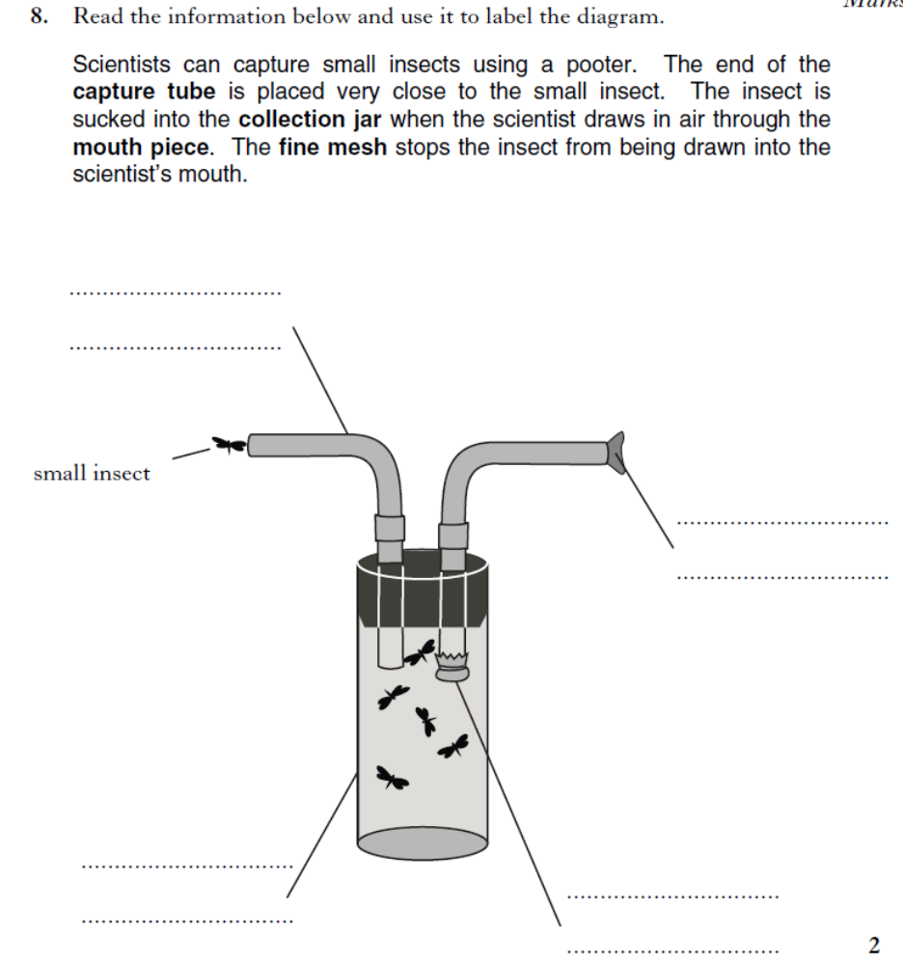
12

A variety of plants can be found on a moorland, including bell and ling heather, cotton grass, bog moss and the sun dew plant. These plants are not randomly distributed. Each is found in a particular area where the conditions are right for its growth. A belt transect was carried out on a moorland slope. A profile of the slope and the results obtained during the transect study can be seen below.
13
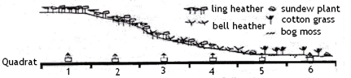
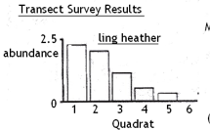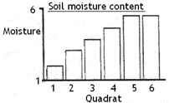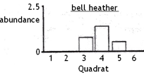
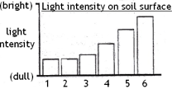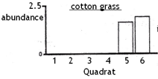

Study these results then answer the following questions-
(1) As you move down the slope, what happens to the abundance of (a) ling heather and (b)
bell heather?
(2) Which type of heather do you think is better suited to living in dry conditions? Give a reason for your choice.
(3) (i) Where on the slope is the cotton grass concentration the greatest?(b) Give a possible reason for the restricted distribution of cotton grass.
(4) (i) What happens to light intensity at the soil surface as you move down the slope?
(ii) Explain the reason for this change in light intensity.
(5) Sundew plants are found only at the bottom of the slope. From the data what conditions sundew plants are likely to need.

14

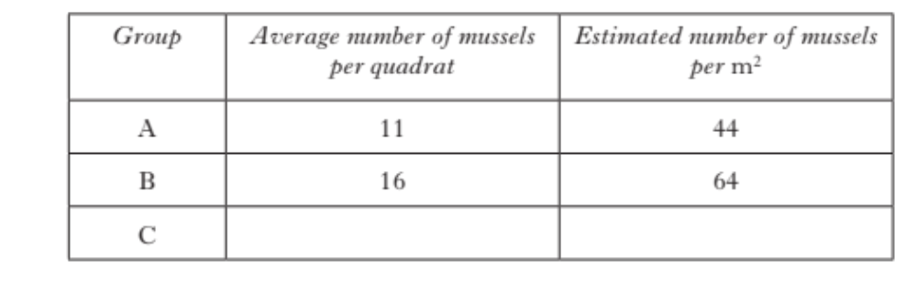


15
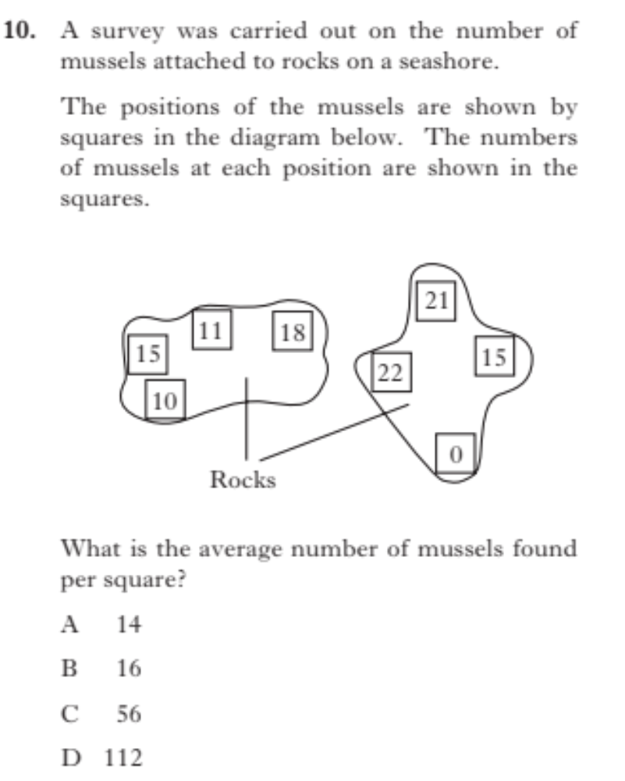

16

Av.
Total
Trap No.
Animals found
Group B
5
4
3
2
1
6
2
2
1
4
Rove beetle
2
1
6
4
2
Ants
0
0
0
0
1
Snails
2
1
0
1
1
Centipedes
1
3
2
2
2
Thrips
8
8
10
8
6
Wolf spider
2
1
3
0
0
Ground beetle
Thrips
Wolf spider
Ground beetle
Rove beetle
Animals found
Group A
1
2
2
8
No.
Pitfall trap survey
Two groups of ecologists carried out a pitfall trap survey in a woodland. Group A set one trap while group B set 5. The results of both groups are shown in the tables below.
Group A concluded that there were four different kinds of invertebrate and that thrips were least common.
a. How many kinds of small animal did Group B find in the woodland? _____ (1)
b. What type of small animal did Group B find to be most common?
__________________ (1)
c. What type of small animal did Group B find to be least common? __________________ (1)
e. Both groups were trying to obtain a specimen of a very rare beetle which is know to live in the woodland. Why did neither group catch one? ______________
_________________________________________________________________ (1)

d. Both groups saw many wasps, bees and flies in the wood but none were caught in the traps. Why? ___________________________________________
_________________________________________________________________ (1)
f. How could the groups improve their chances of catching a rare beetle? _____
_________________________________________________________________ (1)

g. Which group’s data do you think is most reliable and why do you think this? ____________________________________________________________________
_________________________________________________________________ (1)

h. Now present group B’s average result for each insect as a bar graph (4).

