N5 Biology CB4 Proteins HW [GRAPH PAPER NEEDED]

1. The diagram below shows a short section of DNA coding for a protein.
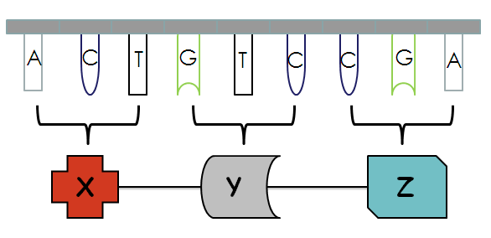
a) The bases are shown on the DNA, name the two components not shown but which make up the backbone of the strand. [1]
b) X, Y and Z will form a protein. What are X, Y and Z? [1]
c) What would happen to the protein if the sequence of bases on molecule W was altered?
[1]
2. Proteins perform a variety of functions in living organisms e.g. enzymes. Name another two functions of proteins. [2]

3. Match up the words in List X to their descriptions in List Y (write the word and the letter). [5]
List Y:
- Enzyme that catalyses breakdown of starch
- Substance that speeds up chemical reaction without being used up
- Biological catalyst made in cells
- Enzyme that catalyses breakdown of hydrogen peroxide
- pH or temperature at which an enzyme works best
- Reaction that involves small molecules forming larger ones
- The molecule on which an enzyme acts
- Word used to explain that enzymes only catalyse one reaction
- Enzyme that catalyses build-up of starch in potatoes
- A change in enzyme structure which stops the enzyme working

List X:
substrate
amylase
denatured
specific
synthesis
catalase
enzyme
catalyst
phosphorylase
optimum

4 a) Cellulase and pectinase are enzymes which break down different parts of plant cell
walls. These enzymes are used in the commercial production of apple juice.

A group of pupils carried out an investigation into the effect of these enzymes on apple tissue at room temperature (22 °C).

The diagram below shows the apparatus used.

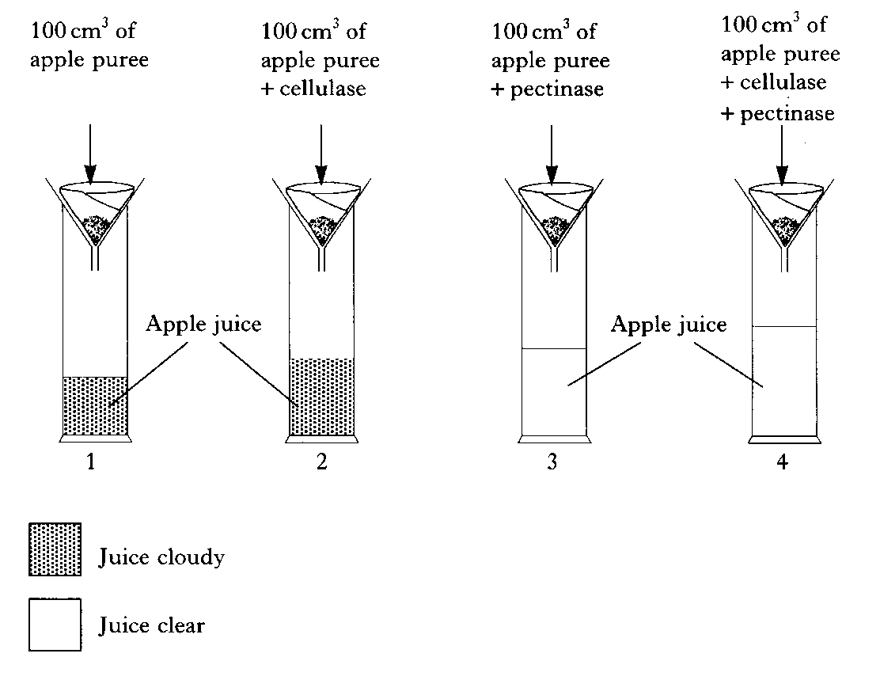
The investigation was left for 24 hours and then the volume of apple juice in each cylinder measured.

The results are shown in the table below.

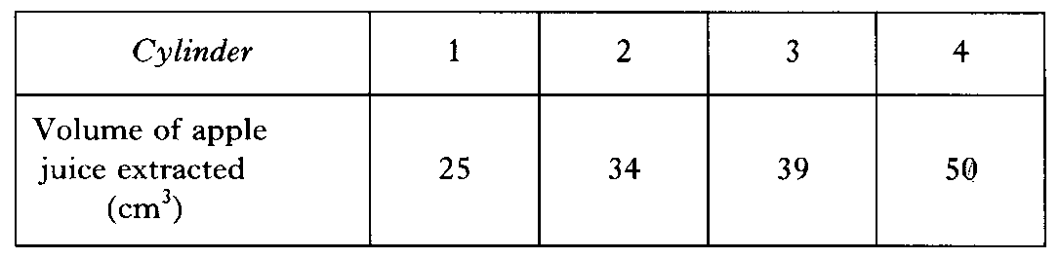

(a) Draw a bar graph of these results. [3]

(b) Calculate how many times greater the volume of apple juice extracted using both enzymes compared to using no enzymes. [1]

(c) Calculate the volume of apple puree required to produce 1000 cm³ of apple juice, if both enzymes were used in the extraction. [1]

(d) Predict the effect on the volume of apple juice which would be extracted if the cylinders were placed in a refrigerator at 3 °C for the 24 hours, instead of being kept at room temperature. [1]

(e) The apple juice in cylinders 1 and 2 was tested for the presence of sugar. A higher concentration of sugar was found in cylinder 2. Suggest an explanation for the presence of the additional sugar in cylinder 2. [1]

(f) State two effects of the addition of pectinase on the extraction of apple juice. [2]

(g) Name two variables, not already mentioned, that must be kept constant in this experiment to get valid results. [2]
5. Explain, using diagrams if needed, why enzymes are specific for only one substrate. [1]

6. The enzyme lipase catalyses the breakdown of fats into fatty acids and glycerol. It can be obtained as a dry powder and made into a solution before use.

The effect of storage at different temperatures on the activity of the lipase solution was investigated. The results are shown in the graph.
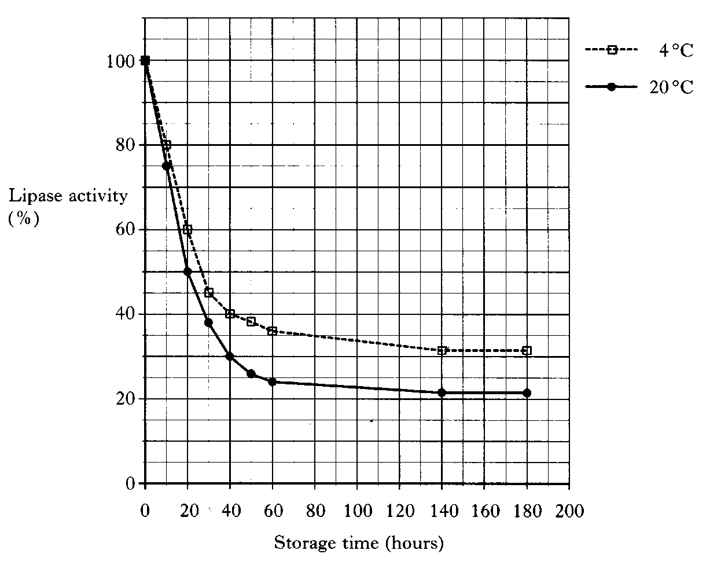
(a) Describe the effect of storage time on the lipase activity at 4ºC. [2]

(b) How long did it take the lipase activity to decrease to 50% when stored at 20 °C? [1]

Total = 25

