S3 Bio BS Homework 3 Heart & Homeostasis

DO NOT write on these sheets Number ______

1 The following diagram shows the structure of the heart.



a) From the diagram select the letters which match the statements below

1. Produces maximum force to push blood round the body
2. Prevents backflow of blood to the right ventricle.
3. Receives oxygenated blood from the lungs. [3]

b) Name the blood vessel that supplies blood to the heart muscle. [1]



2. The diagram on the right represents the heart and circulation.

Which labelled structure is the aorta? [1]



3. Use the internet to find out about **Coronary Heart Disease**. *Write notes* on **what it is**, **what causes it**, its **symptoms** and **risk factors** (factors that increases the chance of getting this disease).

4. The diagram shows some of the events which maintain blood glucose concentration in a mammal.

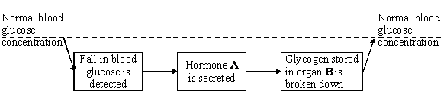

a)   Name (i)      hormone **A** (ii)     organ **B**. [2]

b) Which organ secretes hormone **A**? [1]

c) Name the hormone that would be released after a meal high in carbohydrate? [1]

5. The graph shows the level of anti-diuretic hormone (ADH) in the blood and the rate at which urine is formed.



(a)(i) What is the normal rate of urine production? [1]PS

(ii) What is the highest rate of urine production? [1]PS

(b)(i) What effect does a fall in the level of ADH have on the rate of urine production? [1]PS

(ii) What effect does a rise in the level of ADH have on the rate of urine production? [1]PS