S3 Biology Body Systems Homework 1 Finger Marathon for Muscle Fatigue
YOU WILL NEED a clothes peg, stopwatch & graph paper
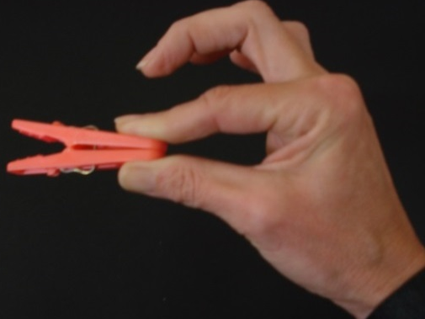
- Find a willing volunteer. They will open/close the peg while you keep the time.
- Ask your volunteer to hold the clothes peg comfortably with the thumb and forefinger of the hand they write with.
- Allow them to practise quickly opening and closing the clothes peg for a few seconds. (Make sure they open it all the way each time.)
- Count the number of times they can open the clothes peg in 30 second intervals, 30s, 60s, 90s. When you say go, your volunteer should squeeze the peg open as fast as they can and count out loud each time they open the peg. They should keep going continuously for 90s but restart counting from 0 each 30s i.e. they count the squeezes in the first 30s then the second 30s then the third 30s.
- Record the RESULTS in a table in your jotter like the one below.
- Switch roles, get the volunteer to time while you squeeze the peg.

time spent squeezing (s) | number of squeezes for 30s interval
 | person A | person B
30
60
90

- Draw a line graph of the two sets of results (both lines on the same graph), stick it into your jotter.
- x axis = time spent squeezing peg (s)
- y axis = number of squeezes for last 30s
CONCLUSION answer these question in your jotter
- What do your results show?
- What process provides the muscles with the energy to move?
[Look in the Cells unit for a clue]
- How did your muscles feel after 90s of squeezing the peg? What caused this feeling?
- What factors could affect your results?
[Clue 1 – look at step2 above.
Clue 2 – are there any differences between you
and your volunteer that may have affected the results?]
- How could you make the results more reliable?

