S3 Biology Biotechnology TEST PRACTICE QUESTIONS
DO NOT WRITE ON THESE SHEETS
GRAPH PAPER NEEDED booklet number
1. An experiment was done to investigate the effect of enzymes and combinations of enzymes on the volume of apple juice extracted. The results are shown in the table below.
Enzyme | Volume (ml)
pectinase | 22
amylase | 17.2
celllulase | 19.2
Amylase + Cellulase | 22.5
Amylase+Pectinase | 23.7
pectinase+ cellulase | 22.5

- What is the average volume of apple juice extracted? (give your answer to one decimal place)
- Which single enzyme gave the greatest volume of apple juice?
- Which enzyme or combination of enzymes gave the greatest volume of apple juice.
- The first time the students did this experiment they boiled the chopped apples and enzymes mixture before filtering. The volumes of apple juice extracted where much lower than the results above. Explain why?
- State two variables, other than temperature, that would have to be kept constant to make a fair test.
2. Another experiment was done in to the effect of pH on the volume of juice extracted using the enzyme cellulase. The results are shown in the table below.
pH | Volume(ml)
1 | 21
2 | 22
3 | 23
4 | 26
5 | 25
6 | 23
7 | 20
8 | 18

a) Collect a piece of graph paper and draw a line graph of these results.
b) What is the optimum pH of cellulase?
c) What improvement would you make to the experiment to find the optimum pH more accurately?
d) How would you make the results more reliable?
REMEMBER TO MARK YOUR WORK REGULARLY
3. Who Am I?
Select the correct word to match the following statements from the three words below. The words can be used more than once. Some statements more than one answer.
◊ enzyme ◊ yeast ◊ bacteria
- added to detergent to digest stains
- a microorganism
- makes ethanol from sugar cane
- added to dough in bread making
- denatured by high temperature
- specific for one substrate
- ferment animal waste to make biogas
- made of protein
4. Look at the diagram of a technique using an immobilised enzyme.
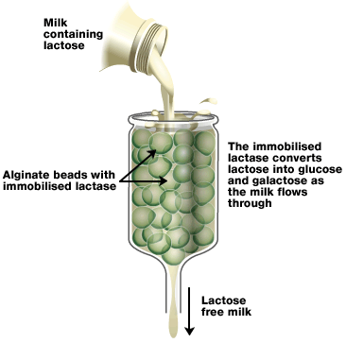
a) Write the enzyme equation for this reaction.
enzyme
[clue – substrate products ]
b) What feature of enzymes means that the product can be continuously poured over them to make the product?
c) It is important to keep the alginate beads below 40ºC. Give a reason for this.
d) The same procedure was carried out using amylase enzyme immobilised on the beads. The milk produced still contained lactose. Give a reason for this.

5. Copy and complete the following sentences
- ______________ variable is the one changed in an experiment.
- ______________ variable is the one measured as your results.
- ______________ variables must be kept constant for a fair test.
REMEMBER TO MARK YOUR WORK REGULARLY

6. As milk sours, there is a change in pH. The following graph shows the pH changes in a sample of milk over 50 hours at a temperature of 20 °C.
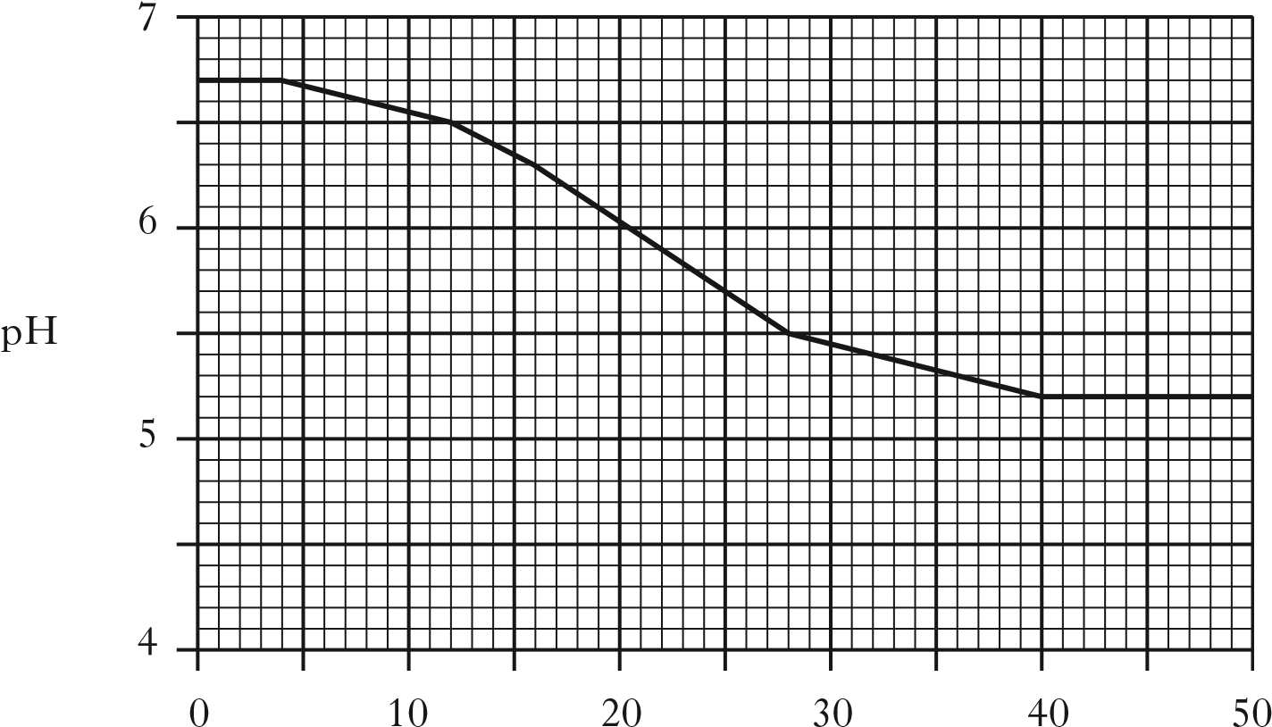
Time (hours)
- Calculate the average decrease in pH per hour.

- Milk is considered to be too sour for human consumption when the pH is less than 6·4. For how many hours would this sample have remained fit to drink?

- The souring of milk is a fermentation process. Name the substrate, product and the type of micro-organism involved.

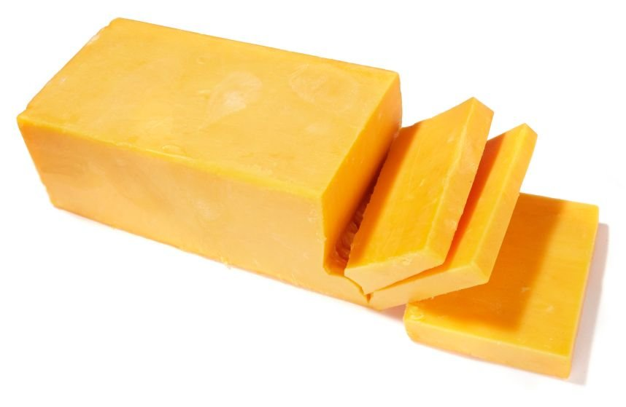
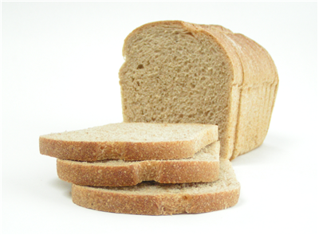
7. a) Name the microorganisms used to make the following foods.
i) ii)

b) Name the enzyme used in cheese making that speeds up the coagulation of the milk. REMEMBER TO MARK YOUR WORK REGULARLY
8. The following diagram shows different temperatures and their effect on bacterial growth.
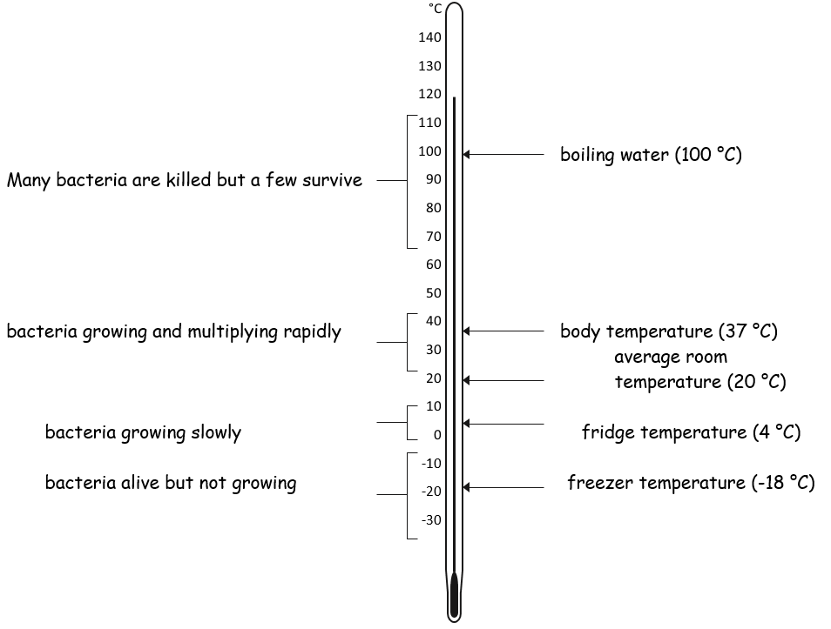
Use the information above to answer the following questions about bacteria.
  - What would be a suitable temperature range to provide optimum conditions for bacterial growth in a fermenter?

  - Why should a fermenter be heated to 120 °C before it is set up?

  - Explain why food should only be kept for a few days in a fridge.

  - Why can food last longer in a freezer than a fridge?

  - If you do not have access to clean drinking water, why is it a good idea to boil water before drinking it?

REMEMBER TO MARK YOUR WORK REGULARLY
9. Sucrose can be broken down into simple sugars using the enzyme invertase. The diagram below represents how this can be done commercially.
Sucrose solution is constantly being added and the products are constantly being removed.
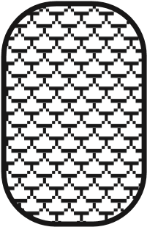
reactor vessel containing invertase

product rich in simple sugars
sucrose
solution

a) What is the name of the technique used to prepare the enzymes so that they do not leave the reactor vessel along with the products?
b) Write the enzyme equation for this reaction.
enzyme

[clue – substrate products ]
c) Suggest a temperature that the reactor vessel should be kept at to allow the enzymes to function at their best.
d) What term is used for the condition where an enzyme works at its best?
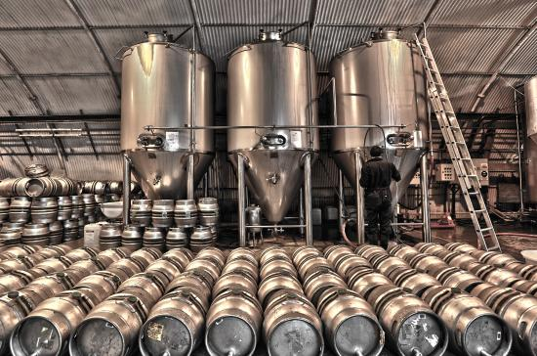
10. During the brewing of beer, ingredients including yeast and malted barley are added to a fermentation vessel.
What gas must be kept out of the reactor vessel when brewing beer ? Explain why.
REMEMBER TO MARK YOUR WORK REGULARLY
11. The concentrations of lactic acid and lactose in a milk sample were measured every two hours for 100 hours. The results are shown in the graph below.
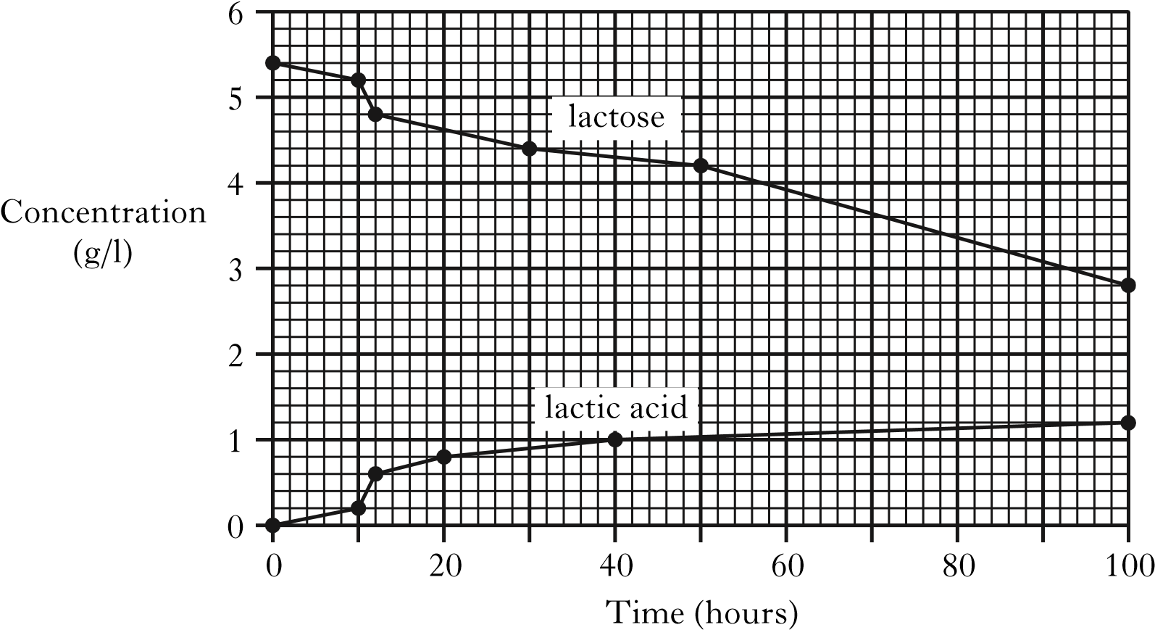
- What evidence from the graph suggests that lactose is converted into lactic acid?
- What evidence from the graph supports the theory that lactose is being converted into compounds other than lactic acid?
- Calculate the average hourly rate of lactose breakdown over the 100 hours of this investigation.
- What type of microorganism converts the lactose into lactic acid?
- What would happen to the pH of the milk over the 100 hours?

12. Yeast is a micro-organism which carries out fermentation.
  - Select the correct word form each box to make the following sentence true.
fungus
bacterium
single
multi
celled
Yeast is a
.

  - Alcohol is a fermentation fuel. Name one other fuel that is produced by fermentation.
  - What advantage is there in using fuels produced by fermentation instead of using fossil fuels (e.g. coal, oil , gas)?
REMEMBER TO MARK YOUR WORK REGULARLY
13. During an investigation into the activity of yeast in bread making, a pupil divided a batch of dough into two equal portions. She added yeast to each portion before placing the dough into identical beakers as shown in the diagrams.
The volume of dough in each beaker was measured at the start and end of the investigation. The results are shown in the table below.
A
B
dough containing
live yeast
dough containing
dead yeast
 | Volume of dough(cm³)
Beaker | At start | At end
A | 100 | 250
B | 100 | 100
- How many times greater was the volume of dough in beaker A at the end compared to the start?
- The production of which substance caused the increase in the volume of the dough?
- Give two factors, not already mentioned, which would need to be kept constant during this investigation
- What was the purpose of setting up control beaker B?
- What type of micro-organism is yeast?
- Give one use of yeast in a manufacturing process, other than the raising of dough.
- Bacteria are used to sour milk in the manufacturing of yoghurt. Name the substance made by the bacteria which causes the milk to sour.

REMEMBER TO MARK YOUR WORK REGULARLY

14. The diagram shows an industrial fermenter. It is fitted with a number of taps which allow substances to be added or removed.

a) Which of the taps, A, B, C, D or E would you open to
i) add nutrients to the mixture?
ii) remove waste gases?
ii) drain off the products?

b) Barley malt extract (a source of sugar), water and yeast were placed in the fermenter and left for several days. The rate of fermentation was measured and the results are shown in the graph below.
- Describe the changes in the rate of fermentation over ten days.
- Suggest a reason for the change in the rate of fermentation between points A and B.
- Which gas must be kept out of the fermenter?
REMEMBER TO MARK YOUR WORK REGULARLY
15. In an investigation into the effectiveness of different detergents, six pieces of cloth were washed. Each of the cloths had identical stains and all variables other than the detergent were kept the same. After washing, the percentage of the stain which had been removed was calculated.
The results are shown in the table.
Name of detergent | Type of detergent | Stain removed  (%)
Whizzo | Non-biological | 50
Spotless | Non-biological | 40
Purity | Biological | 75
Cleano | Biological | 80
Energise | Non-biological | 65
Purgit | Biological | 95

- Use the information on the table to draw a bar graph
- What conclusion which can be drawn from the results.
- What is added to a detergent to make it ‘biological’?

REMEMBER TO MARK YOUR WORK REGULARLY

END OF TEST PRACTICE QUESTIONS

