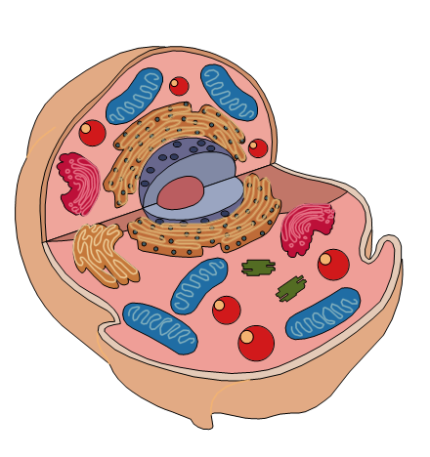
N5 Biology CB1 Homework
B
A
C
- Name and give the function of the organelles labelled in the animal cell opposite. [4]

- Name 3 structures you might find in a plant cell but not in an animal cell. [3]
D
- Identify one similarity and one difference between a plant cell and a fungal cell. [2]

- A newly discovered species was being classified.
The organism is unicellular, has no organelles and several plasmids.
Should it be classified as an animal, a plant, a bacterium or a fungus? Why? [2]

- When examining the cells of a carrot under the microscope, which plant organelle would you not expect to see? Why? [CLUE: think about where a carrot grows] [2]

6. Some organelles within a human liver cell were examined and counted. The results are shown in the table below:
Organelle | Number present
mitochondria | 2 000
vesicles | 7 000
ribosomes | 16 000

- What is the ratio of mitochondria to ribosomes in the cell?[1]
- What percentage of the total number of organelles were mitochondria? [1]
7. If a microscope has an eye piece magnification of 10X and objective lens magnification of 40X, what is the total magnification? [1]
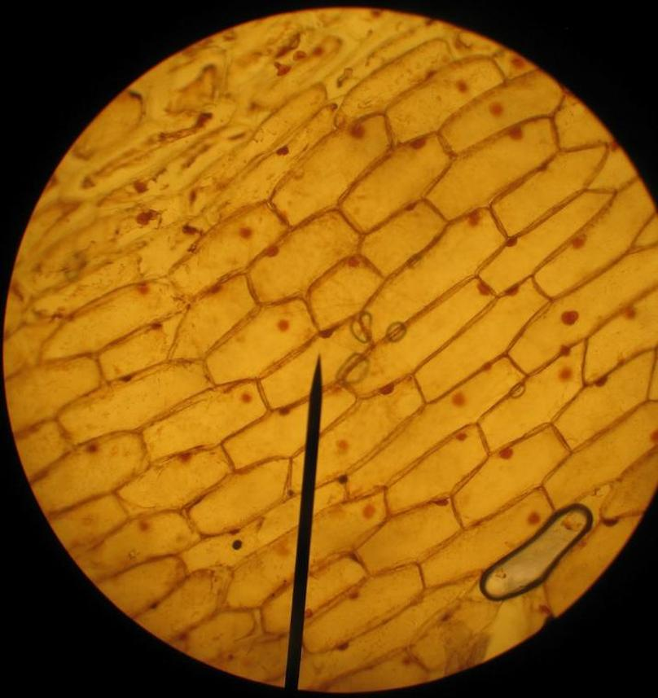
8. An object has a length of 50 um, how long in mm will it appear to be under 500X magnification? [1]

9. The field of view under a microscope is shown on the right. The diameter measures 3.0mm. What is the average length of a cell in micrometres, in the row marked by the back pointer? [1]

[TOTAL = 18 marks]

