N5- Unit 2
MO1-Producing new cells
1-State the function of cell division |  | To increase the number of cells in an organism so that growth and cell replacement/repair can take place.
2-State the biological name for cell division |  | Mitosis
3-State what is the store of hereditary information? |  | Chromosomes, DNA
4-What is meant by “chromosome complement”? |  | Number of chromosomes characteristic to a species, e.g. humans have 46 chromosomes
5-Describe how the daughter cells compare to the original cell |  | They have an identical set of chromosomes which carry the same information as the original cell.
6-Explain why it is important that the chromosome complement is maintained after cell division. |  | If not, cells might die or grow and/or function abnormally.
7- When is the DNA replicated  (2 copies are formed)? |  | Before mitosis.
8-Name the two identical strands that make up the chromosome after DNA has replicated (copied itself)? |  | Chromatids
9-Describe the stages of mitosis in an animal cell  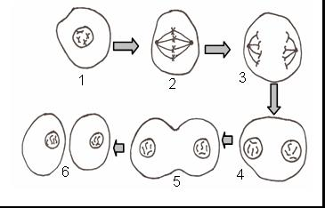  and in a plant cell  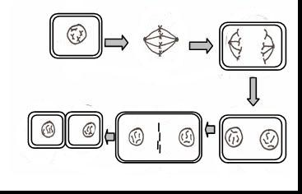 |  | 1-Duplicated chromosomes get shorter and fatter. They become visible and appear as 2 chromatids joined together.  2- The nuclear membrane disappears.  Chromosomes line up at the equator (imaginary plane at the centre of the cell). Spindle fibres attach to chromosomes at the centromere.  3- Spindle fibres contract, chromatids are pulled apart towards opposites poles.  4- The nuclear membrane reforms around the 2 clumps of chromosomes at each end of the cell.  5- The cell membrane pinches and the cytoplasm starts to divide  6- Two identical daughter cells are formed, each with one nucleus.  Plant cell; same as above except for 5:  5- New cell wall forms on a plane at the centre of a cell.
10-What is meant by a “diploid cell” |  | A cell which has 2 identical sets of chromosomes.
11-Which cells in the body are diploid? |  | All cells except sex cells (sperm and egg)
12.What are stem cells? |  | Stem cells in animals are unspecialised cells which can divide in order to self-renew. They have the potential to become different types of cell.
13. What are stems cells needed for? |  | Growth and repair.
14. Give examples of the use of stem cells in medicine |  | - treat burns  - treat leukemia/diabetes
15-Describe specialisation in cells |  | A process whereby cells have changed their shape or metabolism to carry out a particular function (i.e. job).
16-What is the purpose of specialisation? |  | Specialisation of cells leads to the formation of a variety of cells, tissues and organs.
17-Summary of the body organization  (Hierarchical organization of the body) |  | Specialised cells →tissues →organs →systems →Organism
18-Characteristics of multi cellular organisms? |  | Multicellular organisms have more than one cell type and are made up of tissues and organs.
19- What is a tissue? |  | Group of cells working together.
20- What is an organ? |  | The cells in organs are specialised for their function and work together.  Groups of organs work together to form systems
21- Examples of systems |  | Circulatory, respiratory, reproductive etc…
22- For the following cells, state the type of cell, its function and adaptations
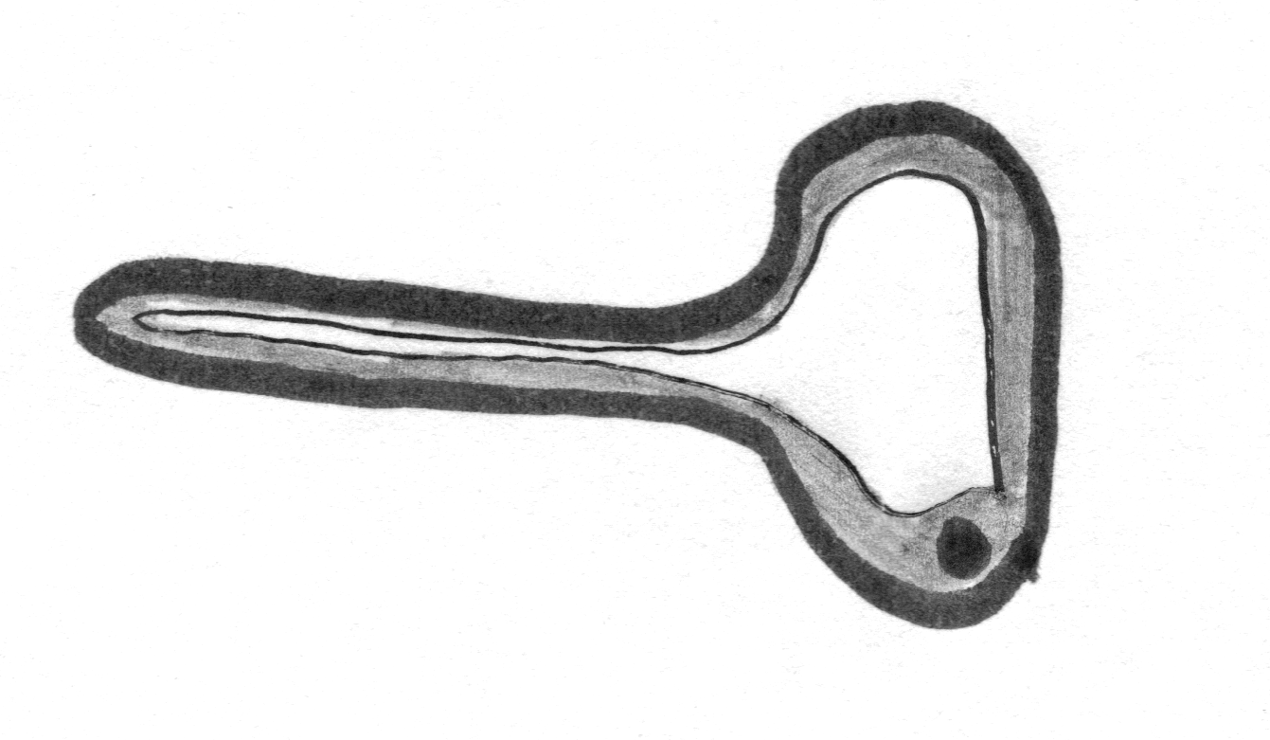 | Type of cell: Plant root hair cell  Function: Absorbs water and mineral from the soil  Adaptations: Long 'finger-like' extension with very thin wall, which gives a large surface area.
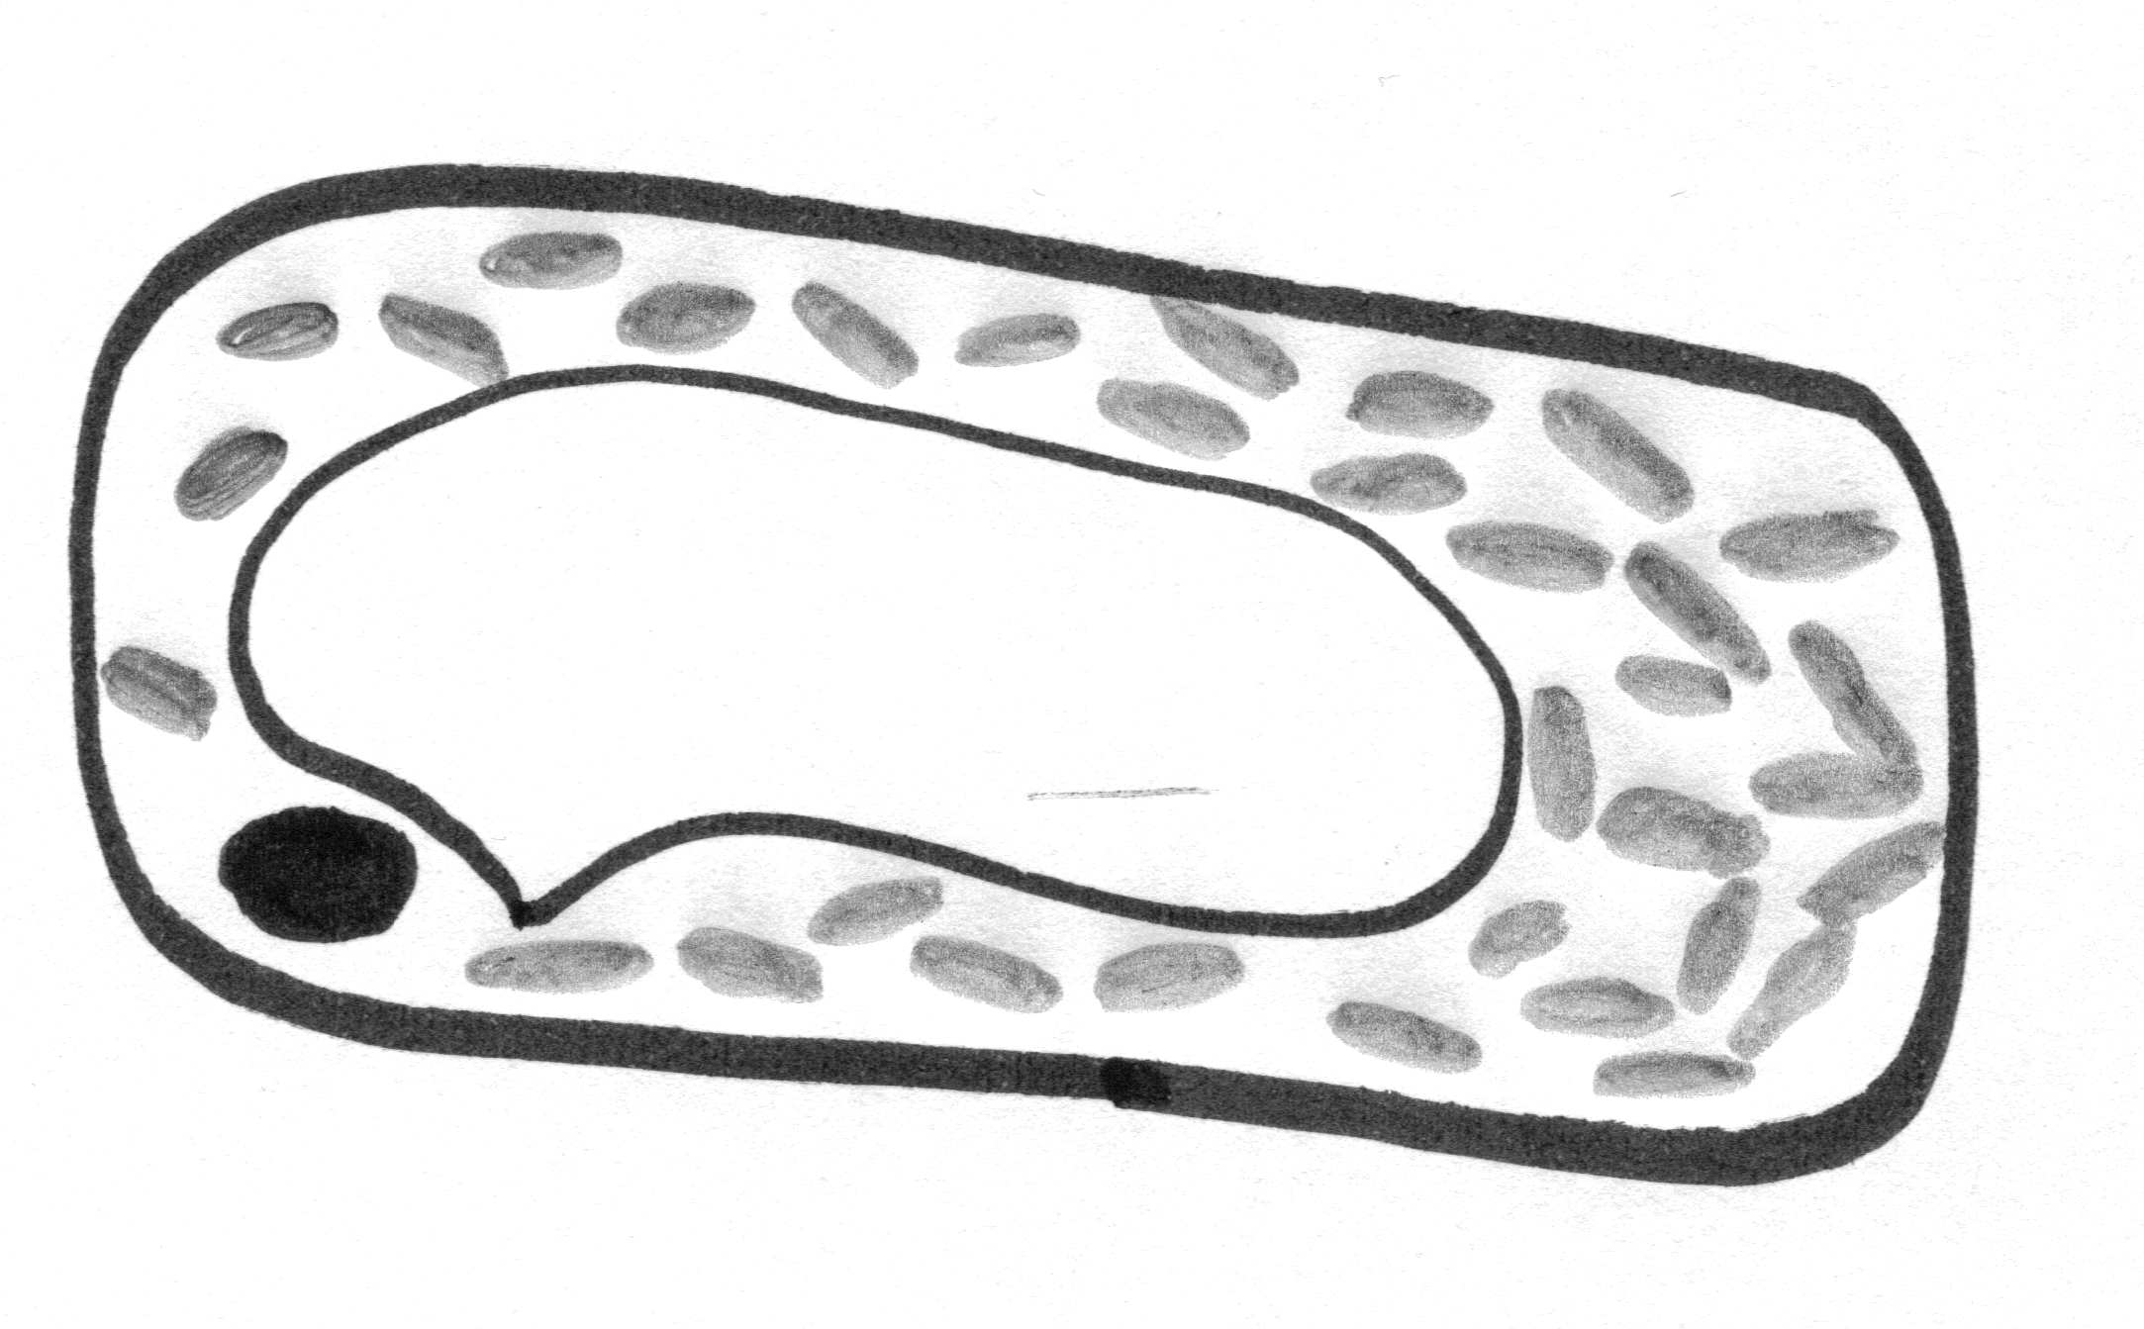 | Type of cell: Plant palisade cell  Function: Site of photosynthesis  Adaptations: Contains lots of chloroplasts
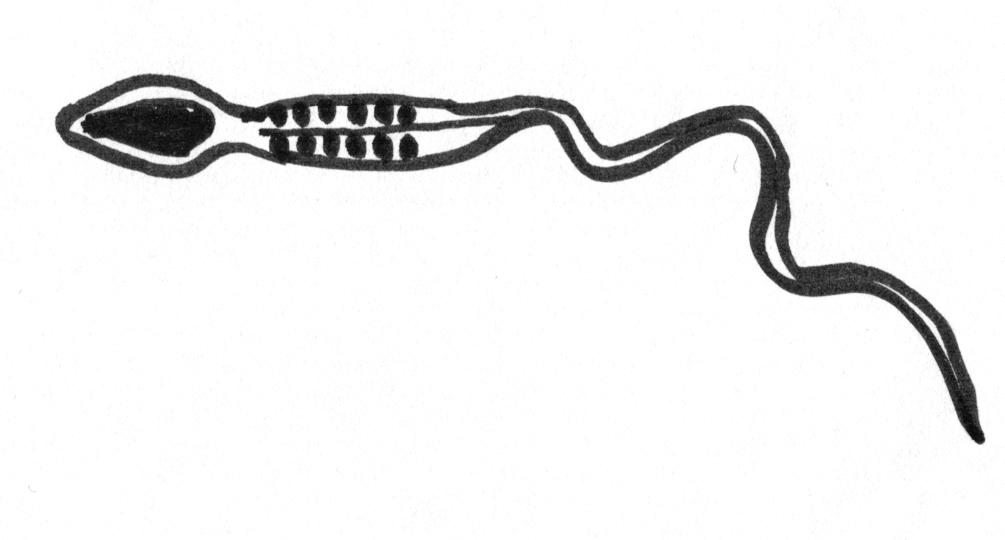 | Type of cell: Sperm cell  Function: reproduction/ fertilization of the egg  Adaptations: has a tail to swim and many mitochondria to release energy.
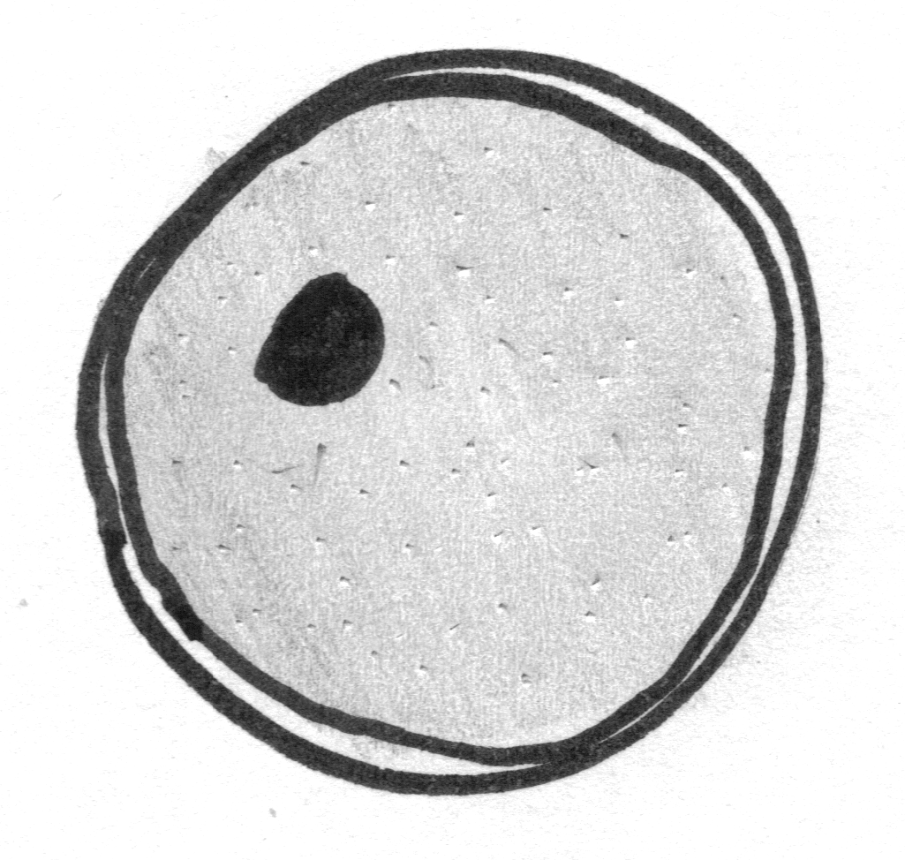 | Type of cell: Egg cell  Function: Reproduction/being fertilized by the sperm cell.  Adaptations: large cell containing food reserves.
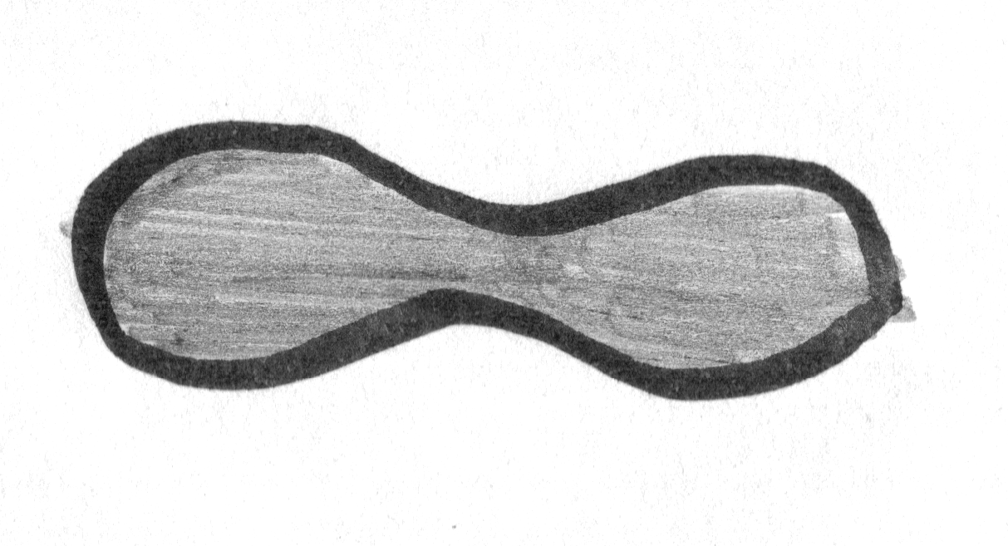 | Type of cell: Red blood cell  Function: carry oxygen  Adaptations: contains haemoglobin to carry oxygen, large surface area to allow diffusion, flexible and small to go through capillaries.

M02- Control – Nerve and hormones
1-Why is internal communication needed? | For survival of multicellular organisms because cell/tissues/organs in multicellular organisms need to work in a coordinated manner.
Nervous control
2- What is the nervous system made of? | The central nervous system and other nerves.
3-What is the CNS made of? | The brain and the spinal cord.
4- Identify the parts of the brain and their function  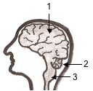 | 1- Cerebrum: the largest part, divided into two halves.  Different regions are responsible for memory, conscious thought, reasoning, intelligence, personality.  2- Cerebellum: controls balance and co-ordination.  3- Medulla: controls automatic functions of the body: breathing, heart beat, etc…
5- What is a stimulus? Other name for it? | A change in conditions that is detected by a receptor (e.g. sense organ). Other name: sensory input.
6- Describe the function of the sensory neuron. | To pass the message from the receptor to the CNS.  The CNS processes the information from our senses which needs a response
7- Describe the function of the motor neuron? | Motor neurons enable the response to be brought about by the CNS. It can be a rapid action from a muscle or a slower response from a gland.
8- Describe the function of an inter neuron (also called relay neuron)? | A nerve cell operating within the CNS. Processes information from the senses that require a response.
9- In what form is the message carried along a neuron? | Electrical impulses carry messages along neurons.
10- What is the name of the gap found between 2 neurons? | A synapse.
11- How is the message passed from on neuron to the next? | Chemicals transfer these messages across synapses.
12- What is a reflex action? | It is a fast, automatic response which requires no input from the brain.
13-What is the purpose of a reflex action? | Reflex actions either protect the body from damage (e.g. removing hand from heat, pupil of the eye becoming smaller in bright light to protect the sensitive cells at the back of the eye from damage, sneeze) or help its normal functioning (e.g. swallowing).
14- Describe how a reflex action works, using the simple model of a reflex arc.  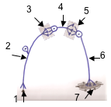 | Receptors (1) are stimulated (e.g. pain) and send a nerve impulse though the sensory neuron (2).  From the sensory neuron, the message has to pass through a synapse (junction, 3) before it reaches the inter neuron (4) in the spinal cord.  From the inter neuron, it crosses another synapse (5) and travels down a motor neuron (6) which stimulates a muscle to contract (7) (e.g. jerking movement of the hand).
Hormonal control
15-Features of hormones |  | - Chemical messengers  - Made of protein  - Carried in the bloodstream
16- What releases hormones directly into the blood stream and why? |  | Endocrine glands release hormones in the blood stream so that they can travel to target tissues and trigger responses.
17- How are hormones perceived by the target tissue? |  | A target tissue has cells with complementary receptor proteins for specific hormones.
18- How are hormones specific to only a particular tissue? |  | Only the target tissue has cells with the specific hormone receptors for a particular hormone.
19-What does the shape of the receptor depend on? |  | The sequence of amino-acids of the protein receptor.
20- Which organ detects changes in blood glucose level? |  | The pancreas.
21-How is blood glucose concentration regulated? |  | By the action of two hormones produced by the pancreas; insulin and glucagon
22- Explain the role of insulin in the control of blood glucose levels. |  | When blood glucose level increases, the pancreas releases more insulin, which travels to the liver where it activates enzymes in the liver cells to convert glucose into glycogen.
23- Explain the role of glucagon in the control of blood glucose levels. |  | When the blood glucose level decreases, the pancreas releases more glucagon, which travels to the liver where it activates enzymes in the liver cells to convert glycogen into glucose.  (When GLUCose is GONe, you need GLUCAGON)
24- What is diabetes? |  | Inability of the body to regulate blood glucose levels.
25- Give two reasons for the recent increase in the number of people with diabetes in Scotland |  | - Poor diet  - Lack of exercise

MO3- Reproduction
Sexual reproduction in animals
1-What is the biological name given to sex cells? |  | Gametes
2-Meaning of haploid? |  | Haploid: a cell which nucleus contains only 1 set of chromosomes. In animals, only gametes are haploid.
3-Male gamete  - name  - features  - site of production |  | - sperm  - has head and tail section and many mitochondria  - testes
4-Female gamete  - name  - features  - site of production |  | - egg or ovum  - has a large store of food in its cytoplasm  - ovaries
5-Identify the main parts of the male reproductive system.  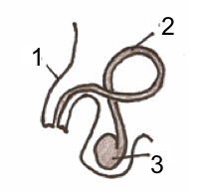 |  | 1- Penis: allows internal fertilisation  2- Sperm duct: carries sperm from testes to penis  3- Testes: male gonad where sperm is produced.
6-Identify the main parts of the female reproductive system.  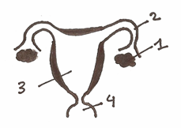 |  | 1- Ovary: female gonad: produces and releases eggs.  2- Oviduct: collects egg and push it toward uterus with the beating of hair-like cilia.  3- Uterus: where the embryo implants and develops.  4- Vagina: where sperm is deposited
7-What is fertilization? |  | Fertilisation is the fusion of the nuclei of the two haploid gametes to produce a diploid zygote.
8-Where does fertilization take place in land animals? |  | In the oviduct of the female reproductive system.
9-What is a zygote? |  | The first diploid cell formed after the fusion of the two haploid gametes.
10-What happens following fertilization? |  | The zygote divides and forms the embryo.
Sexual reproduction in Plants
11-Identify and describe the function of the parts of a flower  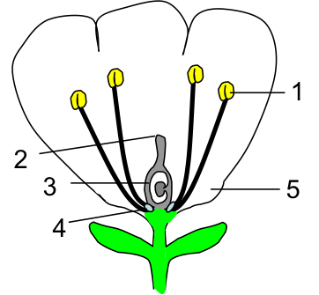 |  | 1- Anther: produce male gamete (sex cell)  2- Stigma: sticky platform on which pollen is deposited.  3- ovary: produces ovule containing female gamete  4- Nectary: produce nectar (sugary liquid to attract pollinator)  5 - Petal: attract pollinators + protection of sexual organs
12- What is pollination? |  | When a pollen grain is transferred from an anther to a stigma.
13-Describe the differences between insect and wind pollinated flowers. |  | Insect pollinated flowers have bright petals, scent and a nectary  Wind pollinated flowers have their anthers and stigma hanging in the air and are not bright or scented
14- Describe the growth of the pollen tube and the fusion of gametes. |  | After landing on the stigma, the pollen grain germinates, i.e. it grows a pollen tube which eventually reaches the ovule. The male gamete travels down the pollen tube to fuse with the female gamete to form the zygote (Fertilisation)
15-Describe the stage following fertilization. |  | The zygote divides to form an embryo. The embryo will form part of the seed.
MO4- Variation and inheritance
1- What is the cause of the observed variation within species? | The combination of genes from two parents.
2- What is discrete variation?  Examples  Type of inheritance | Changes in values for a characteristic which are clear-cut and fall into separate categories.  E.g. blood group, type of ear lobe (free-attached), ability to roll tongue, pea flower colour, pea colour.  Single gene inheritance (controlled by 1 gene only).
3- What is continuous variation?  Examples  Type of inheritance | Characteristic for which there is a range of values, between a minimum and a maximum.  E.g. human: height, foot size  Plants: height, tree girth  Polygenic inheritance (controlled by more than 1 gene).
4- What is the most common type inheritance and variation? | Polygenic inheritance and continuous variation.
5- State what genes are. | Genes are parts of chromosomes
6-State what controls a characteristic (e.g. type of ear lobe, blood group, height) | Inherited characteristics are controlled by the two forms of a gene.
7- State the name given to the different forms of a gene | Alleles
8-State the meaning of homozygote (1) and heterozygote (2). | (1) Organism with 2 identical alleles for one gene  (2) Organism with 2 different alleles for one gene
9- Explain what is meant by phenotype.  Identify examples of phenotypes of the same characteristic. | Phenotype: the external expression of a feature controlled by one or more genes.  Examples of phenotypes for the same characteristic:  Hair colour: blond, brown  Ability to roll tongue: roller, non-roller  Seed shape: round, wrinkled
10- Explain what is meant by dominant and recessive alleles | Dominant is the characteristic that is shown in the phenotype whether there are one or two copies of the allele present  Recessive is the characteristic that can be masked by the presence of the dominant allele
11- Explain what is meant by genotype. How is it represented? | The set of genes an organism possesses,e.g. combination of genes in a gene pair.  - Genotype is represented by 2 letters (one letter for each allele). Dominant alleles are shown as capital letters, recessive alleles are shown in small caps.
12- Identify using letters the successive generations of a cross. | Parents: P  First generation: F1 (First filial)  Second generation: F2 (Second filial)
13- For a cross between two homozygotes parents of different phenotype.  - State what is the phenotype of the first generation  - Predict the proportion of the phenotypes of the second generation | All F1 organisms have the phenotype of the dominant allele. They are said to be uniform.  A ratio of 3:1  3 showing dominant phenotype.  1 showing recessive phenotype.
14- Explain differences between observed and predicted figures in monohybrid crosses. | - random nature of fertilisation  - death of embryo – death of seedlings
15- In family trees, by which individual should you start to work out genotypes? | Individuals with the phenotype of the recessive allele.

MO5- Transport Systems Plants
1- Explain the need for a transport system in plants. | - to transport water and minerals from roots to leaves where photosynthesis takes place.  - to transport food (i.e. sugar) from leaves to parts of the plant which do not make food
2- Which parts of the plant are involved in water transport? | - root hairs.  - xylem vessels.
3-Why is water needed by the plant? | - to transport dissolved minerals  - for photosynthesis
4- Describe the uptake of water from soil by plant roots and the role of the root hair cells in this process | Water moves into roots by osmosis from the area of high water concentration in the soil to the area of low water concentration in cells. Root hair cells increase the surface area of root for osmosis.
5- Describe the role of the xylem | Transport water and soluble minerals after they enter root to leaves where it is needed for photosynthesis.
6- Characteristics of the xylem | - made of dead xylem vessels  - strengthened by lignin rings
7- Explain why the strengthening of the xylem vessels is needed? | Xylem cells are lignified to withstand the pressure changes as water moves through the plant.
8- Describe structure of xylem vessels 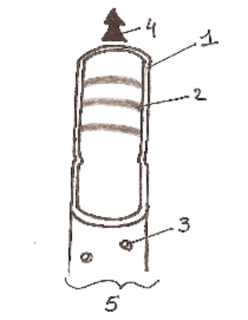 | 1- cell wall  2- ring of lignin  3- pit ( allow water and minerals to reach neighbouring cells  4- direction of the flow (from roots to leaves)  5- xylem vessels
9- Describe the role of the phloem | Sugar is transported up and down the plant in living phloem, food from food-producing cells is transported to other parts of the plants where it is needed (root, buds and fruits).
11- Describe the structure and function of cells in the phloem.  Identify the different parts from a diagram.  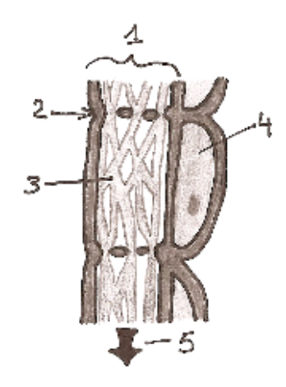 | - Phloem is made of two types of living cells: sieve tubes and associated companion cells.  - sieve tubes: cells arranged as a tube with perforated cell wall in between (sieve plate). Strands of cytoplasm transport sugar from cells to cells. No nucleus are found in sieve tubes.  - companion cells: have nucleus and cytoplasm, they control neighbouring sieve tubes.  - sieve tube  - sieve plate  - strands of cytoplasm  - companion cell  - direction of flow, from photosynthesising cells in leaves to cells that cannot produce their own food.
12- Describe the external features and internal structures of a leaf in relation to its function in gas exchange.  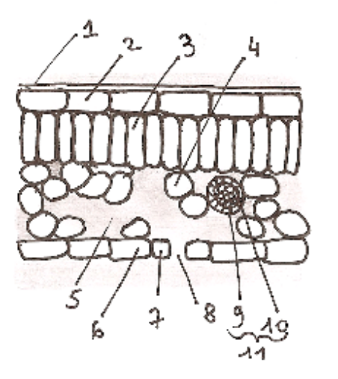 | 1- Waxy cuticle: prevents water loss  2- Upper epidermis: protection  3- Palisade mesophyll: where most photosynthesis takes place.  4- Spongy mesophyll: where some photosynthesis takes place. Cells are not compactly packed and have a large surface area exposed to air. This allows the diffusion of carbon dioxide into cells.  5- Air spaces: allow free movement of gases inside the leaf.  6- Lower epidermis: protection  7- Guard cells: specialist cells which open or close the stoma  8- Stoma 9- Phloem 10- Xylem  11- Veins: hold xylem and phloem
13- State how gases go in and out of leaves. | Through holes called stomata which are found mostly on the lower surface of leaves.
14- State which gases go out and which go in through these holes | - CO₂ (in for photosynthesis, out from respiration)  - O₂ (mostly out from photosynthesis, in for respiration at night)  - Water vapour (out whenever stomata are opened)
15- Which type of leaf cell requires water for photosynthesis? | Palisade and mesophyll cells
16- What is transpiration? | Transpiration is the process of water moving through a plant and its evaporation through the stomata.
17- What is the process responsible for water loss when the stomata are opened? | Evaporation
18- What environmental conditions would produce the greatest transpiration rate? | Warm and windy.
19- Summarise the path of water through the plant | 1-Enters root hair by osmosis  2-Move by osmosis through root cells towards the xylem.  3-Transpiration pull takes water up the xylem.  4-Water leaves xylem and enters palisade and mesophyll cells by osmosis.  - Water evaporates from mesophyll cell into air spaces.  - Water vapour exits the plant through stomata
MO6- Transport systems in animals
Blood
1- What does blood contain? | Plasma, red blood cells and white blood cells.
2- What does blood transport? | Nutrients, oxygen and carbon dioxide.
3- Describe the features of a red blood and which allow it to transport oxygen efficiently. | - biconcave in shape: increases surface area for rapid diffusion of gases  - contains haemoglobin which binds to oxygen to form oxyhaemoglobin for efficient transport of oxygen.  - no nucleus: more space to carry haemoglobin.
4-Describe the interaction of haemoglobin and oxygen as an equation when the blood reaches:  -the lungs  -the tissues | In lungs:  Haemoglobin + oxygen → oxyhaemoglobin  In tissues:  Oxyhaemoglobin → haemoglobin + oxygen
5-Function of white blood cells? | They are part of the immune system and involved in destroying pathogens.
6-What is a pathogen? Examples? | Pathogens are disease-causing micro-organisms.  Examples: bacteria, viruses, fungi.
7-Name the 2 main types of white blood cells and describe their mode of action. | Phagocytes carry out phagocytosis by engulfing pathogens.  Lymphocytes produce antibodies which destroy pathogens.
8-Characteristics of antibodies? | - binds to the pathogen which triggers its destruction  - Each antibody is specific to a particular pathogen.

The heart
9- Identify the four chambers of the heart  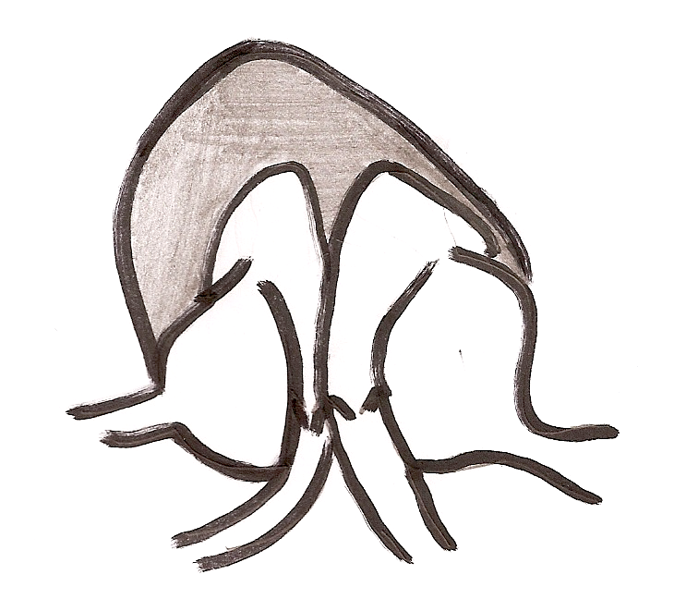  1  2  4  3 | 1- Right atrium (Plural atria)  2- Right ventricle  3- Left atrium (Plural atria)  4- Left ventricle
10- Describe the path of blood flow through the heart and blood vessels connected to it.  5  6  7  84  1  2  3  4 | Blood return from organs via the vena cava (5) and enters the right atrium (1). When the right atrium is full, the blood is squeezed into the right ventricle (2). The muscular wall of the right ventricle contracts and pushes the blood through to the pulmonary artery (6) towards the lungs.  Blood return from the lungs via the pulmonary vein (7) and enters the left atrium (3). When the left atrium is full, the blood is squeezed into the left ventricle (4). The muscular wall of the left ventricle contracts and pushes the blood through to the aorta (8).
11-Describe the positions and functions of the heart valves.  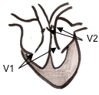 | When the atria are full, the blood is squeezed into the ventricle and valves (V1) prevent its return to the atria.  When the ventricles are full, the blood is squeezed towards the arteries (pulmonary artery and aorta) and valves (V2) prevent its return to the ventricles.
12-Function of Coronary artery | To bring blood to the heart muscle.
13-Describe the difference in muscle thickness between the left and the right ventricles and explain. | Describe: The wall of the left ventricle is thicker than that of the right ventricle.  Explain: The left ventricle must generate greater force to push the blood to all the body cells whereas the right ventricle needs to generate lesser force to push the blood to nearby lungs.
Blood vessels
14-Describe the structure of the arteries | Arteries have thick, muscular walls, a narrow central channel
15-Describe the function of the arteries | Arteries carry blood under high pressure away from the heart.
16-Describe the structure of the veins | They have thinner walls and a wide channel. Veins contain valves to prevent backflow of blood and carry blood towards the heart.
17-Describe the function of the veins | Veins carry blood under low pressure back to the heart.
18-Describe the structure of the capillaries | Capillaries are thin walled and have a large surface area as they form networks at organs and tissues,
19-Describe the function of the capillaries | They allow efficient exchange of materials between the blood and cells.
MO7- Absorption of materials
1-Why are oxygen and nutrients from food absorbed in the bloodstream and transported? | To be delivered to cells for respiration
2-What does need to be removed from cells into the bloodstream? | Waste materials such as carbon dioxide.
3-What allows exchange of materials at cellular level? | The fact that tissues contain capillary networks.
4-Describe the common features of surfaces involved in the absorption of materials. | - large surface area  - thin walls  - extensive blood supply
5-What is the effect of these features on absorption? | It increases its efficiency.
6-What is the function of lungs? | Gas exchange organs.
7-Where does gas exchange take place? | In the alveoli
8-What features of the alveoli are important for its function? | For a more efficient diffusion of gases: alveoli have a large surface area, thin walls and a good blood supply.
9-Describe the path of oxygen in the alveoli | From cell of the alveoli wall to cells of the capillary wall to plasma to blood cells.
10-Explain why O₂ and CO₂ dioxide move in and out of cells. | They diffuse down their concentration gradient.
11-Describe the features of lungs and how these allow them to function efficiently. | - They consist of a large number of alveoli providing a large surface area for absorption of materials.  - The alveolar walls are thin to allow rapid diffusion of oxygen and carbon dioxide.  - the alveoli are surrounded by a network of many capillaries.
12-Where are nutrients from food absorbed in the body? | Into the villi in the small intestine.
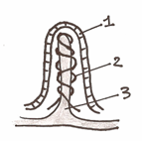  13-Structure and function of a villus | - (1) one cell thick layer allows fast absorption of nutrient.  - (2) rich blood supply. Blood capillaries: carry away glucose and amino-acids.  - (3) lacteal (lymphatic vessels): absorb  fatty acids and glycerol (the products of fat  digestion).

